**Agile Project Management**

**Sim Project- Team Based Response (Total Points 100)**

**Group 11**

By:

Rutwika Mohanty

Soumya Ranjan Mishra

Prashant Bhapkar

Akshay Raj

**Sprint 0 - Week 1 (Possible Points: 4)**

**Sprint Backlog (1 Point)**

* Paste the screen shot of your Sprint Backlog below **(1 Point):**

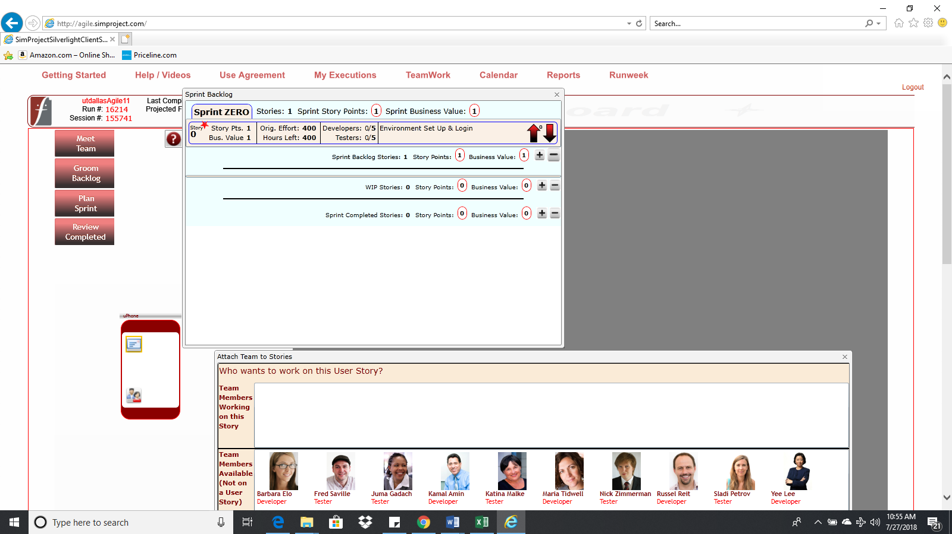

**Task Board (1 Point)**

* Paste the screen shot of your Task Board (at the end of this Sprint) below **(1 Point):**

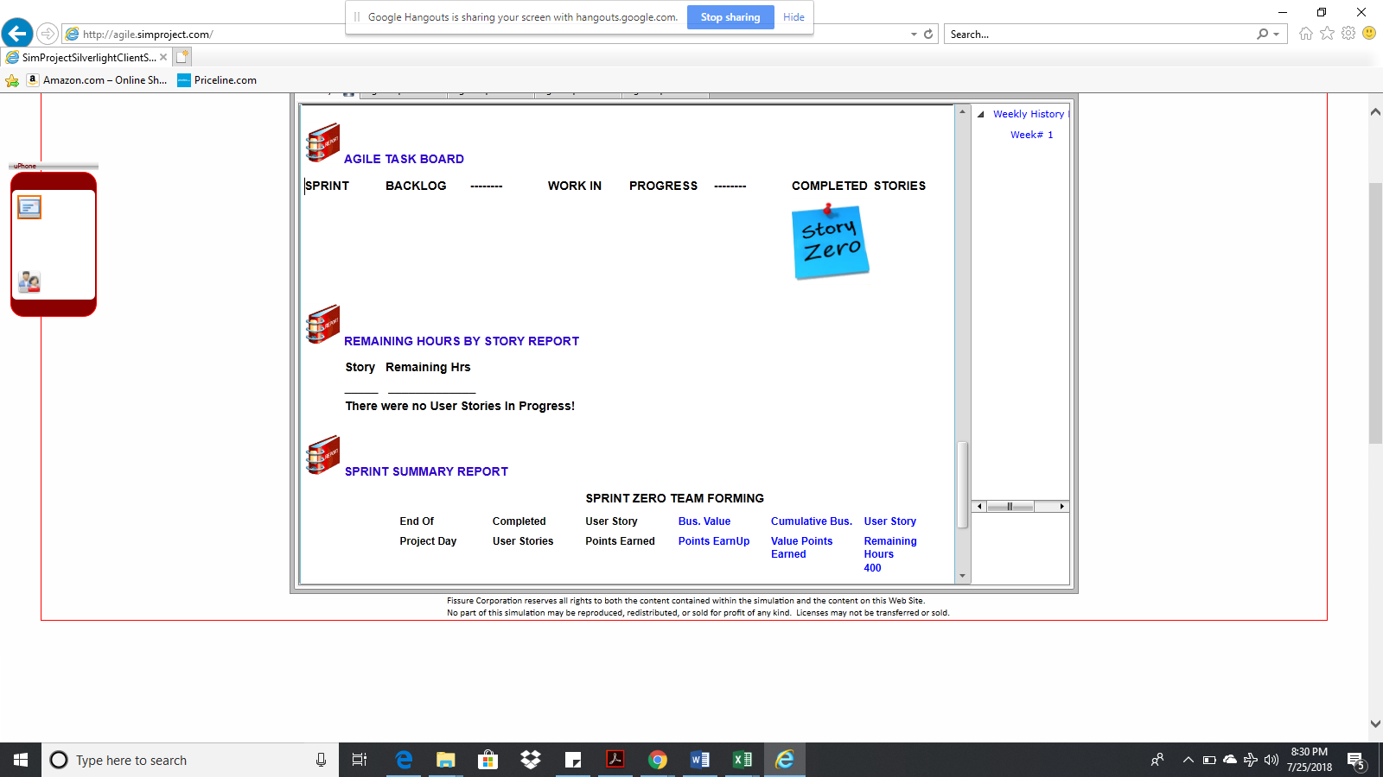

**BurnDown – EarnUp Chart (2 Points)**

* Paste the Sprint 0 Burn Down – Earn Up Chart below:

|  |  |  |  |  |
| --- | --- | --- | --- | --- |
| **Day** | **Planned Velocity** | **Remaining Hours** | **Cumulative Story Points Earned** | **Cumulative Business Value Earned** |
| 0 | 400 | 400 | 0 | 0 |
| 1 | 320 | 395 | 0 | 0 |
| 2 | 240 | 360 | 0 | 0 |
| 3 | 160 | 282 | 0 | 0 |
| 4 | 80 | 178 | 0 | 0 |
| 5 | 0 | 79 | 1 | 1 |

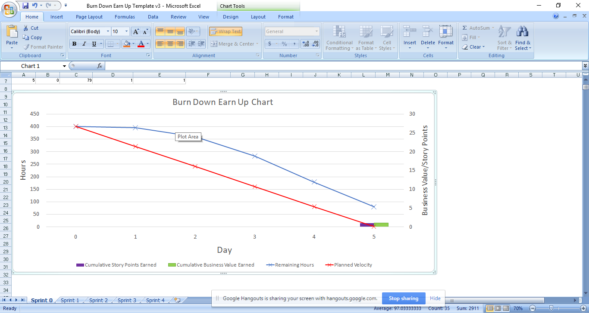

**Sprint 1 - Week 2 & Week 3(Possible Points: 24)**

**Product Backlog (one screen shot for both weeks)**

* Paste the screen shot of your Product Backlog below **(1 Point)**:

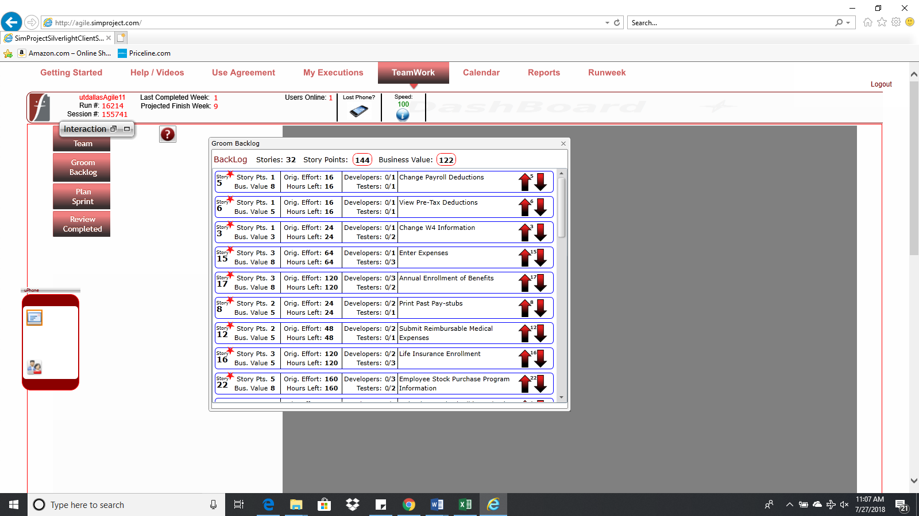

* Please explain what you did in grooming the user stories in your Product Backlog and your reasoning for these decisions**(2Points):**

We have given priority to the essential user stories while grooming the product backlog. Additionally, business value earned per story point, effort hours required to deliver the stories as well as availability of resources to accommodate all the resources were the other factors that were considered.

**Sprint Backlog (one screen shot for both weeks)**

* Paste the screen shot of your Sprint Backlog below**(1Point):**

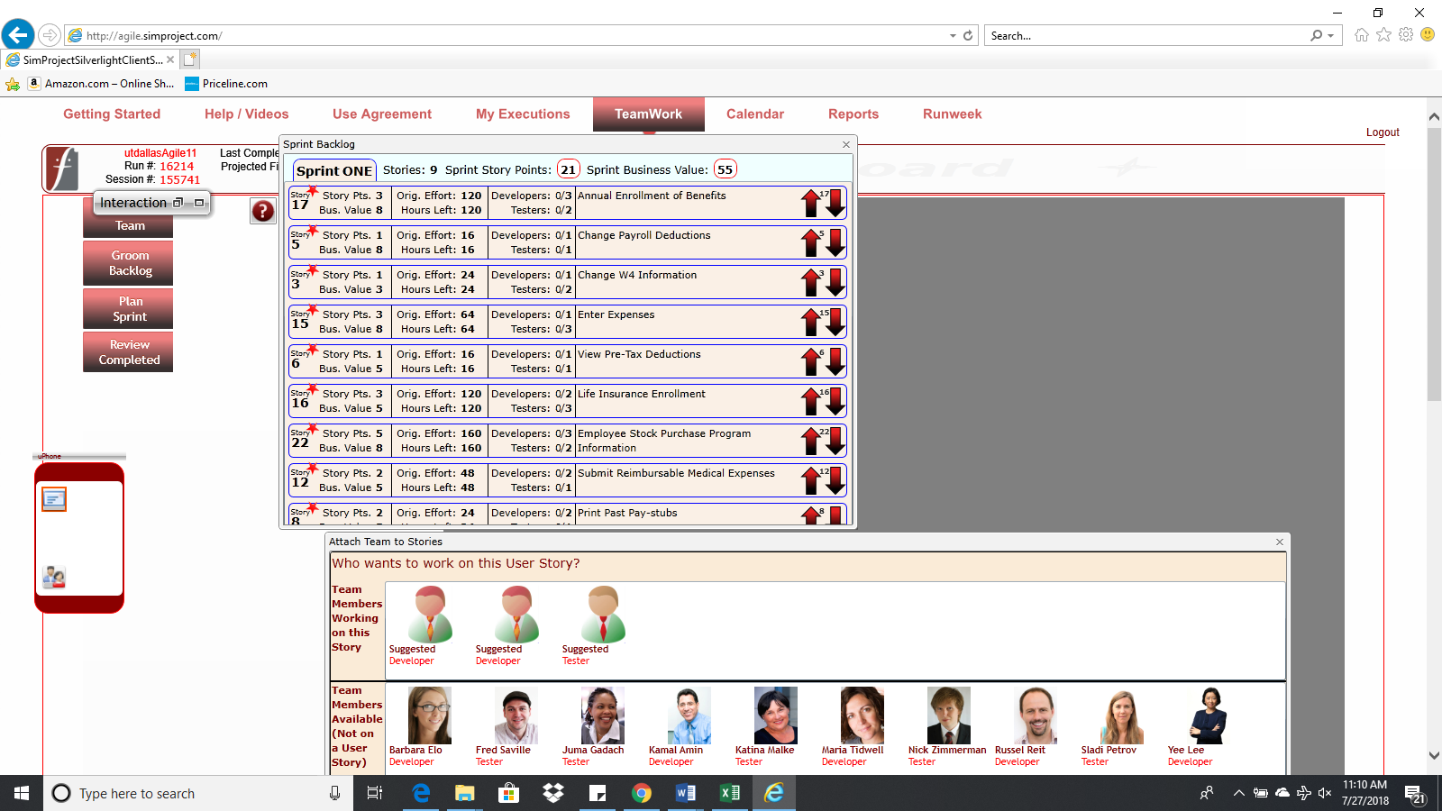

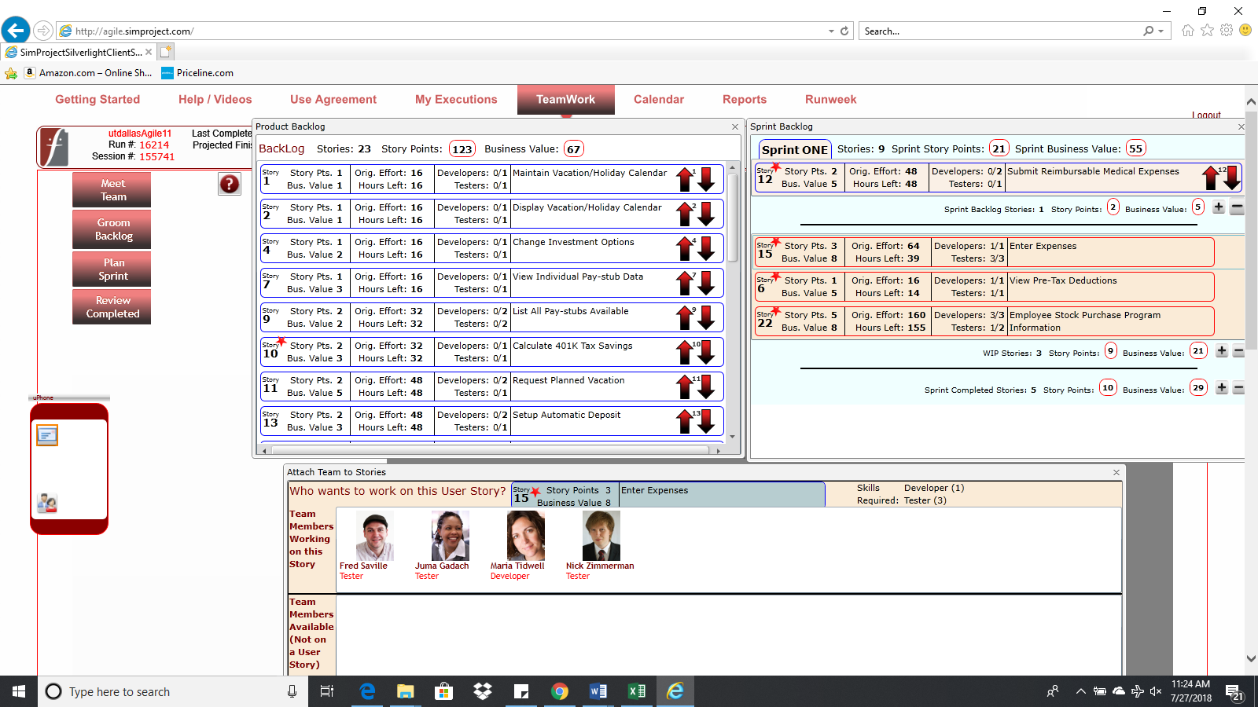

**Calendar**

* Paste the screen shot of your Calendar (one screen shot for 1stweek & one for 2nd week):

1st Week Calendar Screen Shot and explain the reason why you have scheduled these meetings (if any)? **(2 Points)**

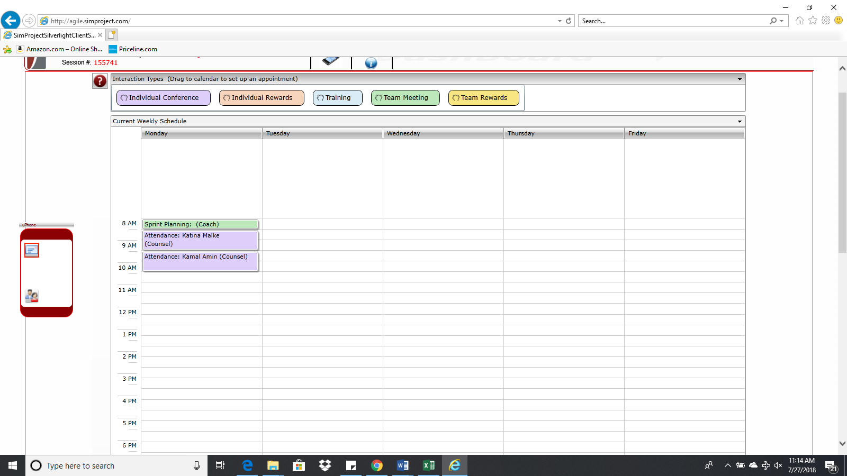

**Explanation:** Sprint planning meeting was scheduled to plan the current sprint. Also, attendance meetings with Katina and Kamal were scheduled separately to counsel them as Katina didn’t turn up on Monday and Kamal on Tuesday. It was necessary to understand the reason of their absence and counsel them if necessary.

2nd Week Calendar Screen Shot and explain the reason why you have scheduled these meetings (if any)? **(2 Points)**

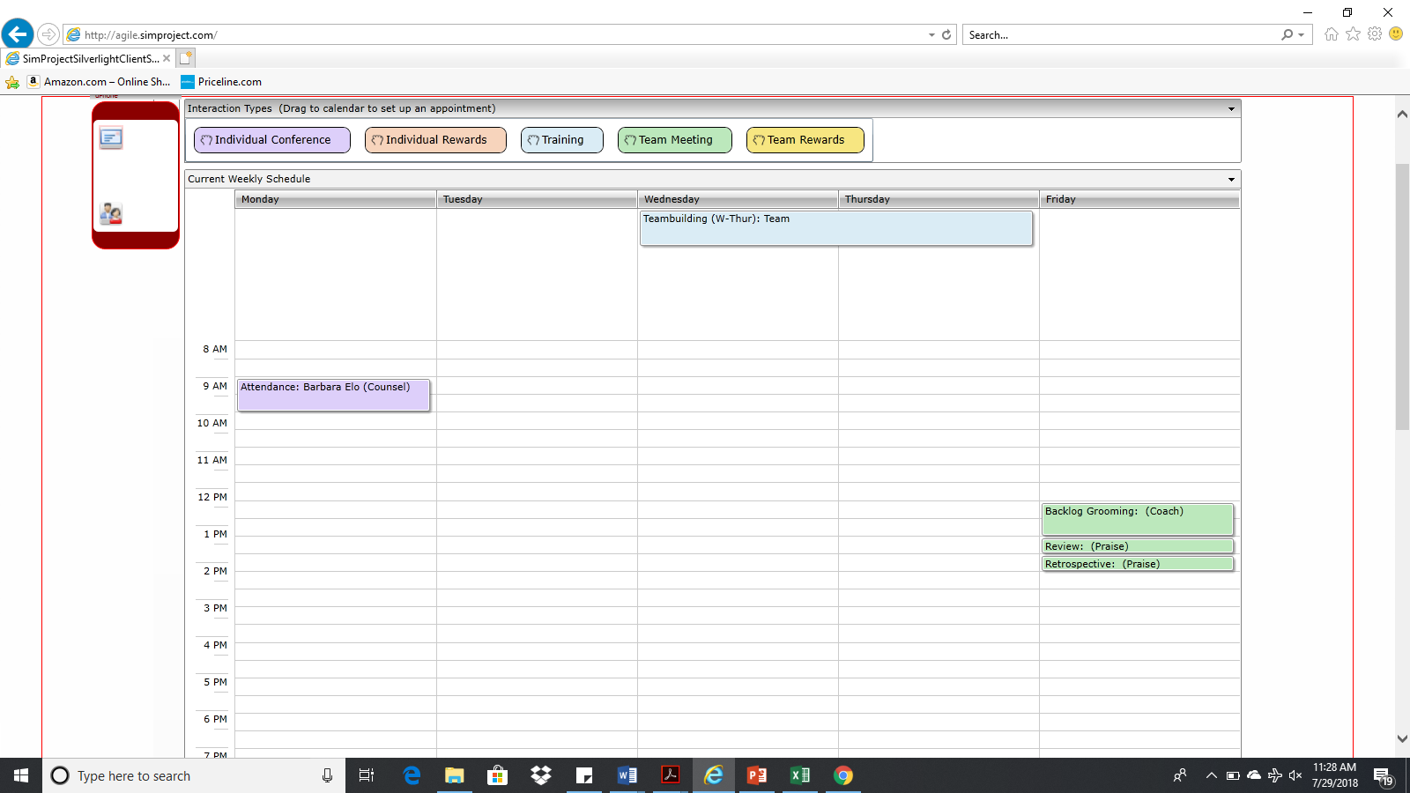

**Explanation:** Barbara was absent on Wednesday. Thus, a meeting was arranged on Monday 9AM to discuss/counsel her frequent work leaves without prior notice. Training session on teambuilding was conducted on Wednesday and Thursday for the whole team. Moreover, backlog grooming for the next sprint was important and hence a meeting was scheduled on Friday at 12PM. Also, meetings for sprint review and sprint retrospective were scheduled for the same day at 1PM and 1:30PM respectively. Everyone was praised for their efforts in the sprint.

**Task Board**

* Paste the screen shots of your Task Boards (one screen shot for 1stweek & one for 2nd week):

1st Week Task Board Screen Shot **(1Point):**

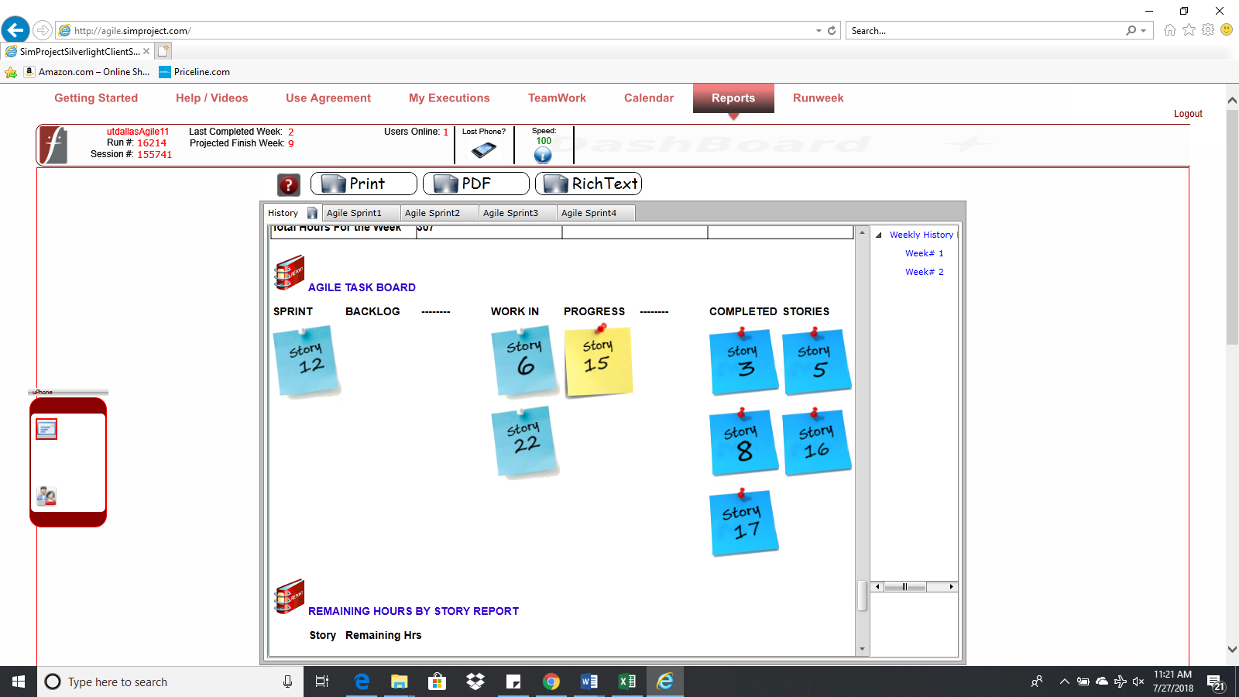

2nd Week Task Board Screen Shot**(1Point):**

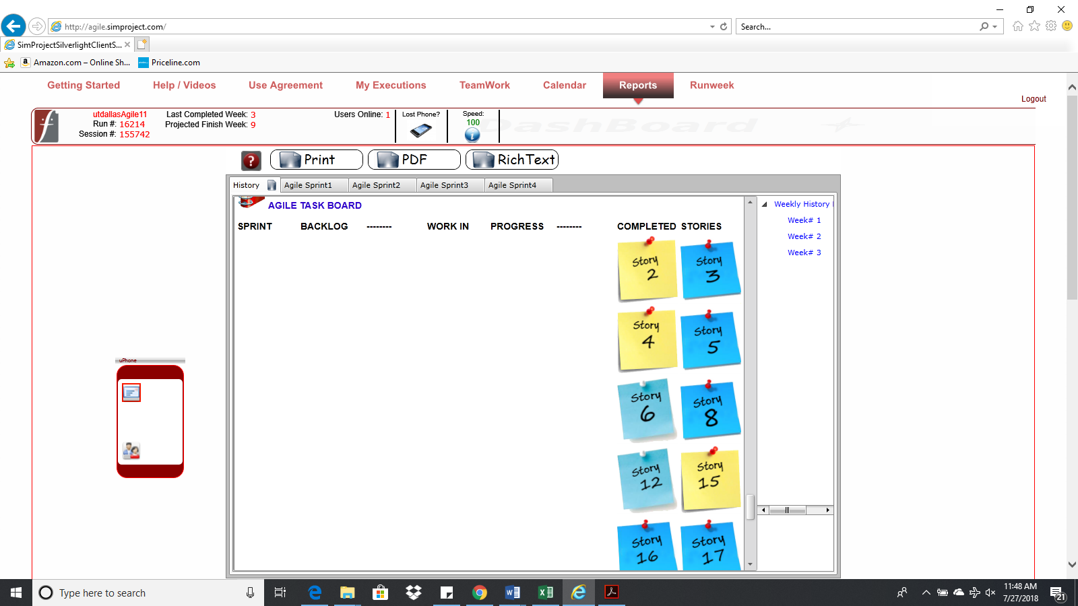

**BurnDown – EarnUp Chart**

* Paste the Sprint 1 Burn Down – Earn Up Chart below**(2Points)**:

|  |  |  |  |  |  |
| --- | --- | --- | --- | --- | --- |
| **Day** | **Planned Velocity** | **Remaining Hours** | **Story points earned** | **Cumulative Story Points Earned** | **Cumulative Business Value Earned** |
| 0 | 800 | 624 | 0 | 0 | 0 |
| 1 | 720 | 552 | 0 | 0 | 0 |
| 2 | 640 | 541 | 2 | 2 | 5 |
| 3 | 560 | 454 | 1 | 3 | 13 |
| 4 | 480 | 361 | 3 | 6 | 18 |
| 5 | 400 | 288 | 4 | 10 | 29 |
| 6 | 320 | 206 | 0 | 10 | 29 |
| 7 | 240 | 123 | 4 | 14 | 42 |
| 8 | 160 | 43 | 5 | 19 | 50 |
| 9 | 80 | 2 | 3 | 22 | 56 |
| 10 | 0 | 0 | 1 | 23 | 58 |

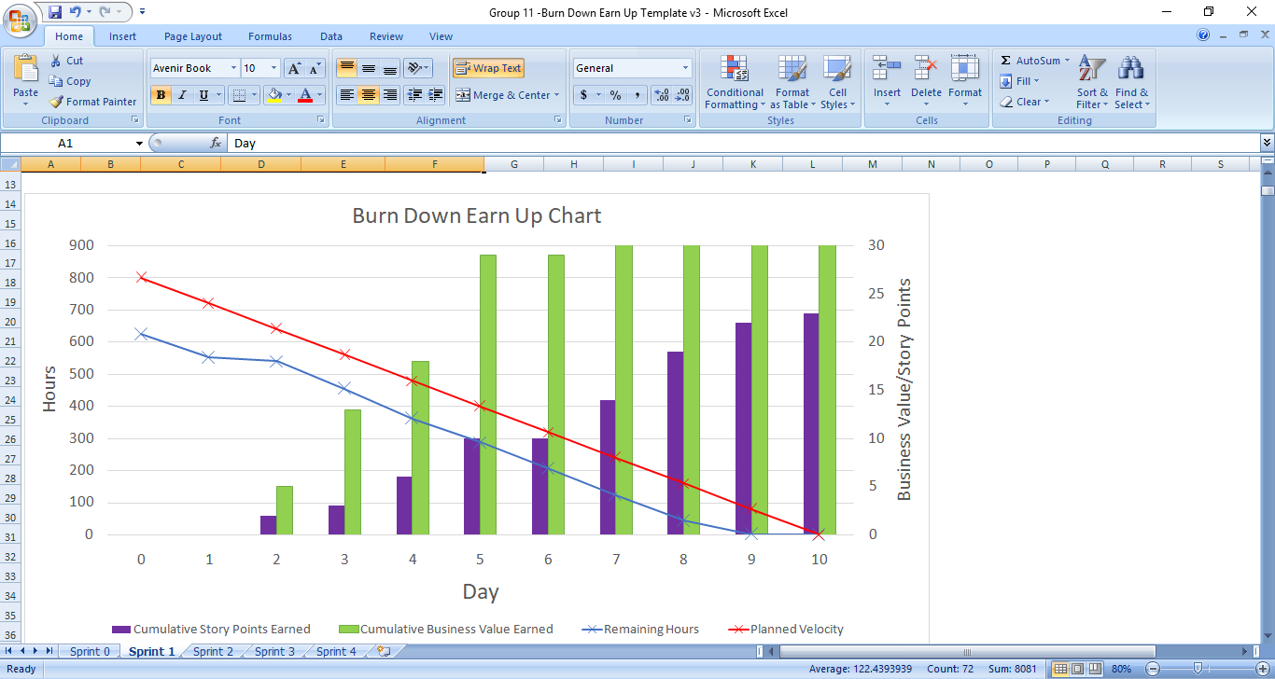

**Retrospective Meeting:**

* How did you do in this Sprint? **(2Points)**

We did quite well in this sprint. We were able to complete all the user stories in the sprint. For the first week, it was a really great performance by the team. The team managed to complete all the user stories in the exact time allotted. There were 0 hours remaining and we must say that sprint execution was perfectly done as far as the execution time is concerned.

* What changes you are planning to make in the next Sprint (if any)? **(2Points)**

We think that the performance of the team was good. We plan to give individual rewards to team members to keep up their morale and encourage them to work in the same way.

**Answer following questions based on this Sprint:**

1. How many hours did your team complete each week in the two weeks of above Sprint? What is your average velocity per week (in hours), and your velocity range (in hours per week), using the lowest and highest hours/week as your range? **(2Points)**

Week 1 hours – 307

Week 2 hours – 279

Average velocity (hours/week) – 312

Velocity range(low) – 288 hours/week

Velocity range(high)- 336 hours/week

2. What is your velocity (in story points) for above Sprint? **(2Points)**

23 story points.

3. Based on the current status of your project, do you believe that you will be able to complete the mandatory (or required) stories in the product backlog within the four sprints planned following Sprint Zero?  Explain your answer. **(2Points)**

Yes, we believe that we’ll be able to complete all the required stories in the product backlog within the four sprints. We are quite confident about our grooming approach and the metrics used for grooming. And it has shown great results at the end of the 1st sprint. Thus, we’re optimistic that we’ll be able to complete all the required user stories within 4 sprints.

4. Based on the current status of your project, do you believe that you will be able to complete all stories in the product backlog within the four sprints planned following Sprint Zero? Explain your answer. **(2Points)**

The velocity in terms of average hours per week is just 312, which is quite less compared to 400 hours. If we want to complete all the user stories, we’ll need to utilize full 400 hours of the week for both the weeks.

**Sprint 2 - Week 4 & Week 5 (Possible Points: 24)**

**Product Backlog (one screen shot for both weeks)**

* Paste the screen shot of your Product Backlog below **(1 Point)**:

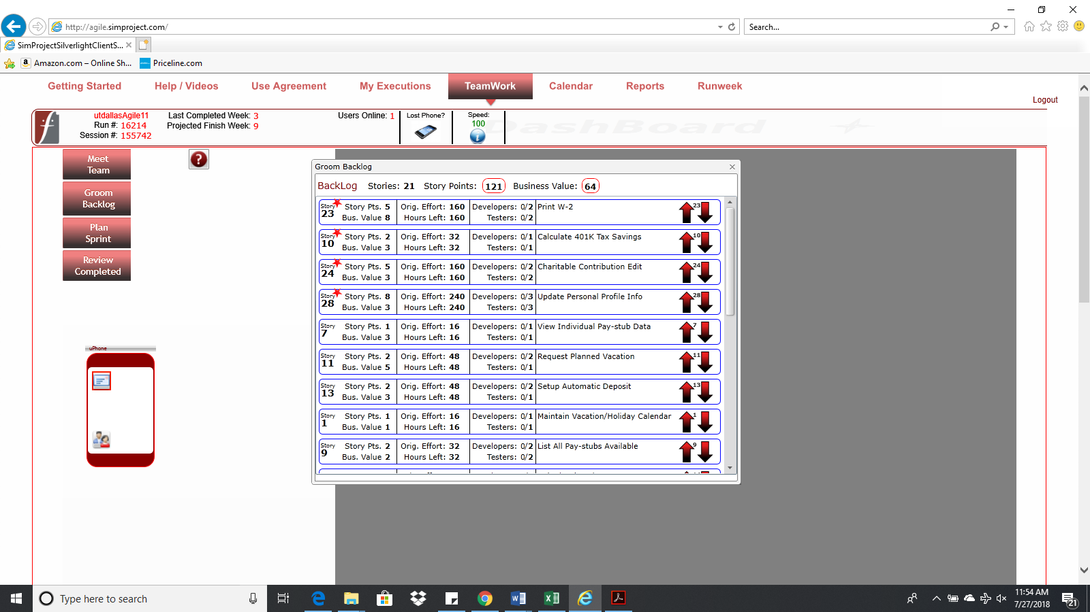

* Please explain what you did in grooming the user stories in your Product Backlog and your reasoning for these decisions **(2Points)**:

We made no changes to the approach used in the first sprint to groom the backlog. The required stories are still given the priority. We considered business value earned per story point as well as efforts hours to groom the stories. Additionally, availability of resources was considered to accommodate all the resources.

**Sprint Backlog (one screen shot for both weeks)**

* Paste the screen shot of your Sprint Backlog below **(1Points)**:

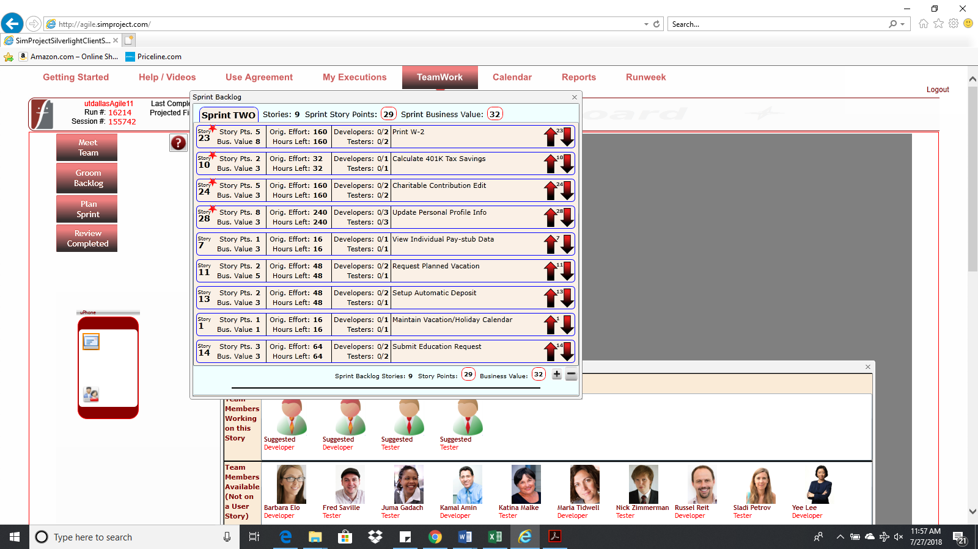

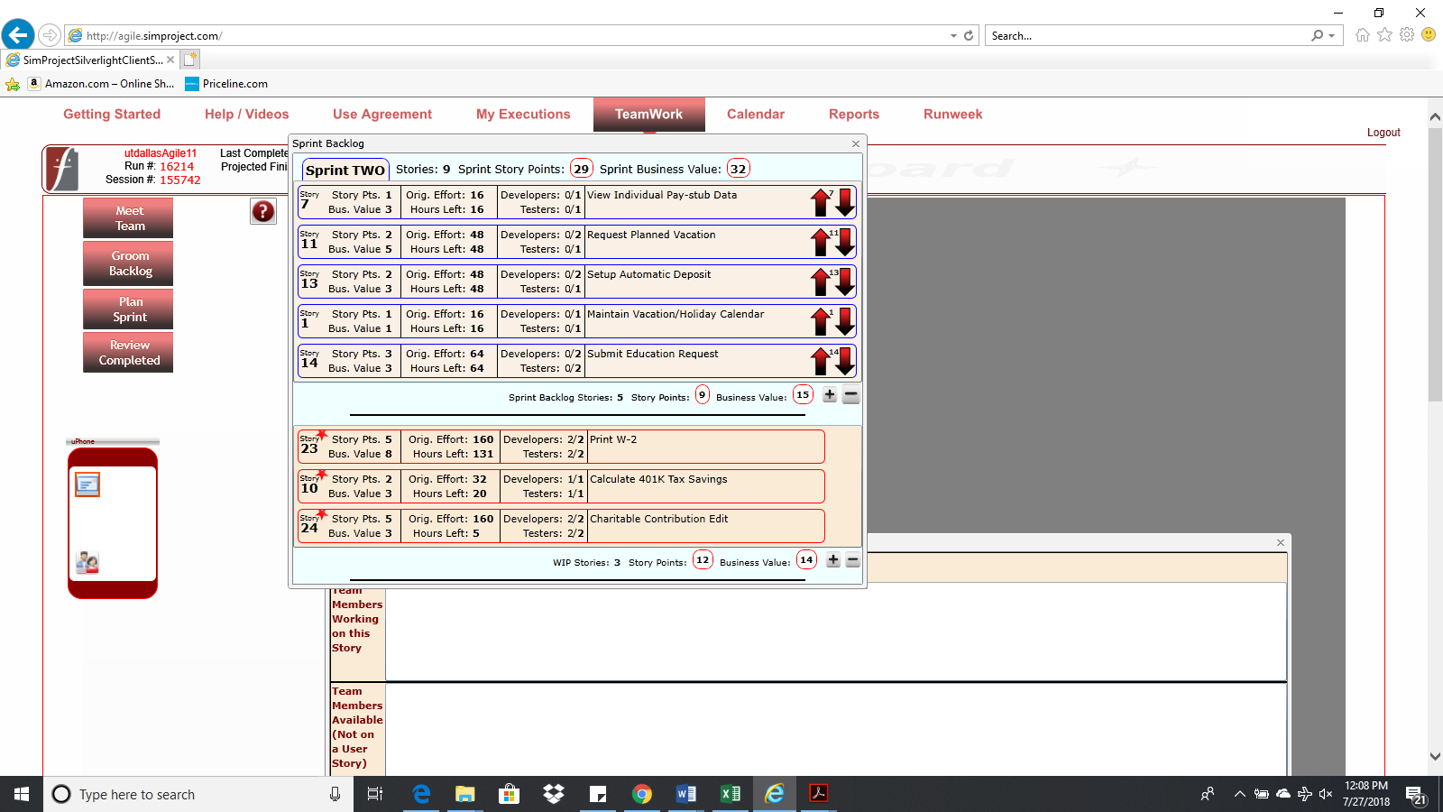

**Calendar**

* Paste the screen shot of your Calendar (one screen shot for 1stweek & one for 2nd week):

1st Week Calendar Screen Shot and explain the reason why you have scheduled these meetings (if any)? **(2Points)**

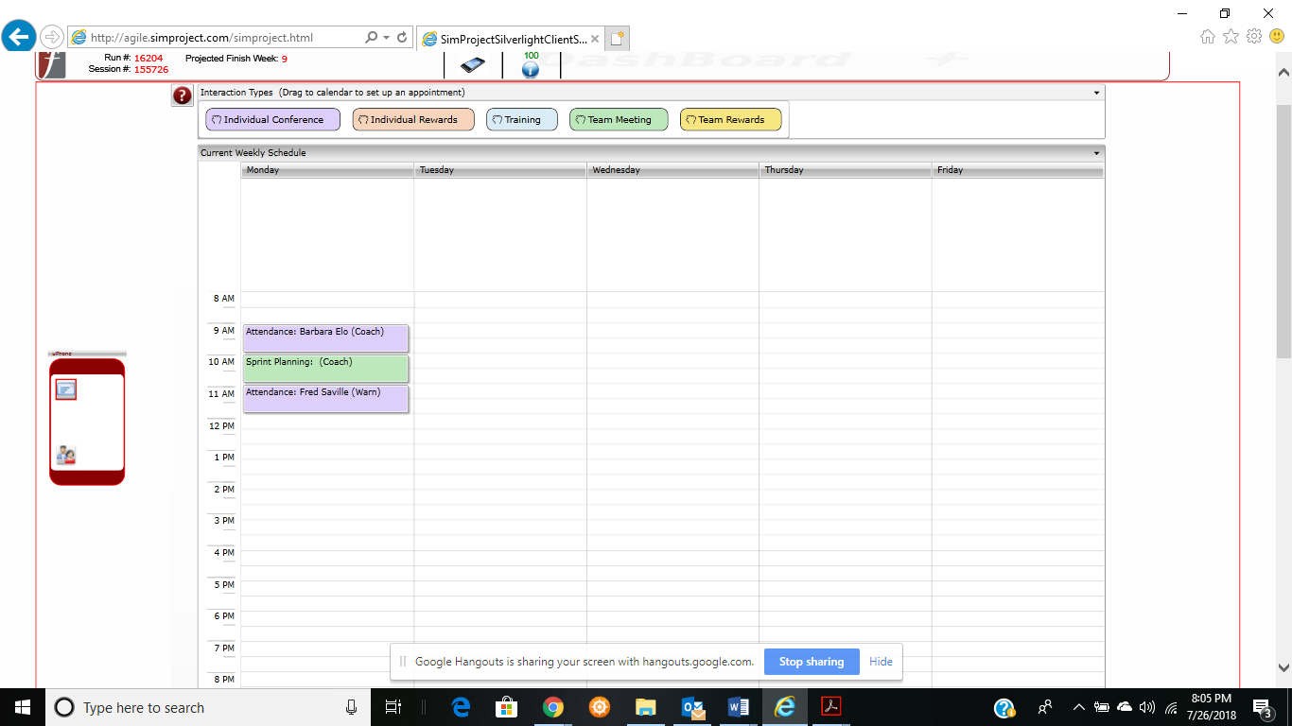

**Explanation:** Barbara didn’t attend the sprint planning meeting on Monday and, she was absent on Thursday. We needed to discuss the reason for that and thus scheduled a meeting with her on Monday at 9AM for 1 hour to coach her. Also, Fred was absent on Thursday. Hence, we scheduled a meeting with him on Monday at 11AM. Apart from that, 1-hour long sprint planning meeting on Monday from 10AM-11AM was conducted to plan the current sprint.

2nd Week Calendar Screen Shot and explain the reason why you have scheduled these meetings (if any)? **(2Points)**

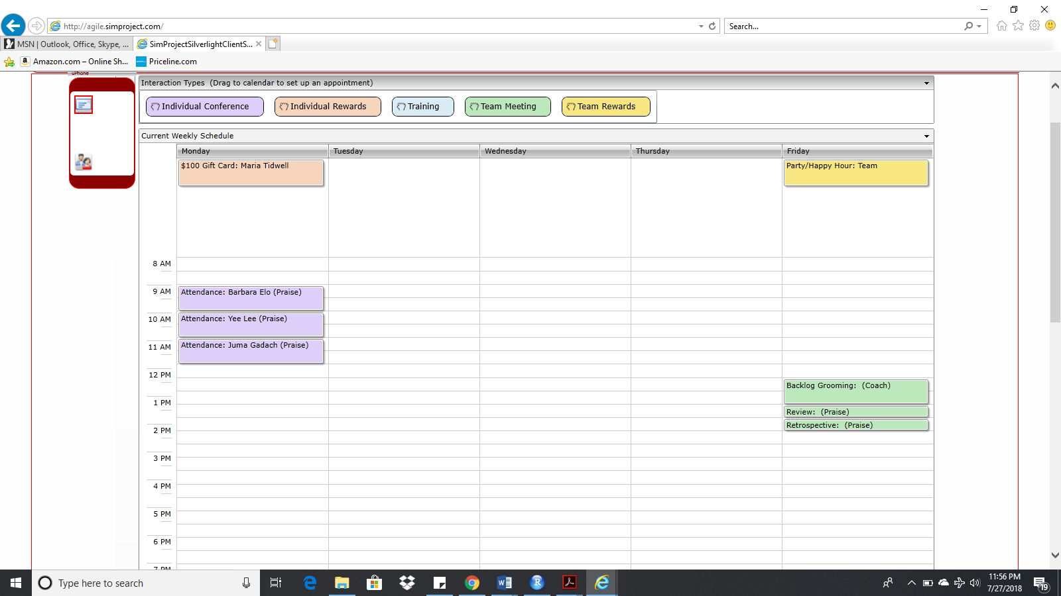

**Explanation:** Barbara and Yee were absent on Tuesday. Also, Juma didn’t turn up to work on Wednesday. To discuss the reasons for that we planned to meet with each one of them separately for 1 hour each as shown in the calendar. Maria was recognized for her exceptional productivity for which we gave her a $100 gift card to encourage her to continue working with the same standards. Also, we planned a backlog grooming meeting to groom the backlog for the next sprint. This meeting was scheduled on Friday for 1 hour from 12PM to 1PM. Also, sprint review and retrospective meetings were scheduled on Friday to discuss the performance of the team in this sprint. Team was praised in both the meetings because of their good work. And, for the same reason we planned a happy hour/party on Friday.

**Task Board**

* Paste the screen shots of your Task Boards (one screen shot for 1stweek & one for 2nd week):

1st Week Task Board Screen Shot **(1Points)**:

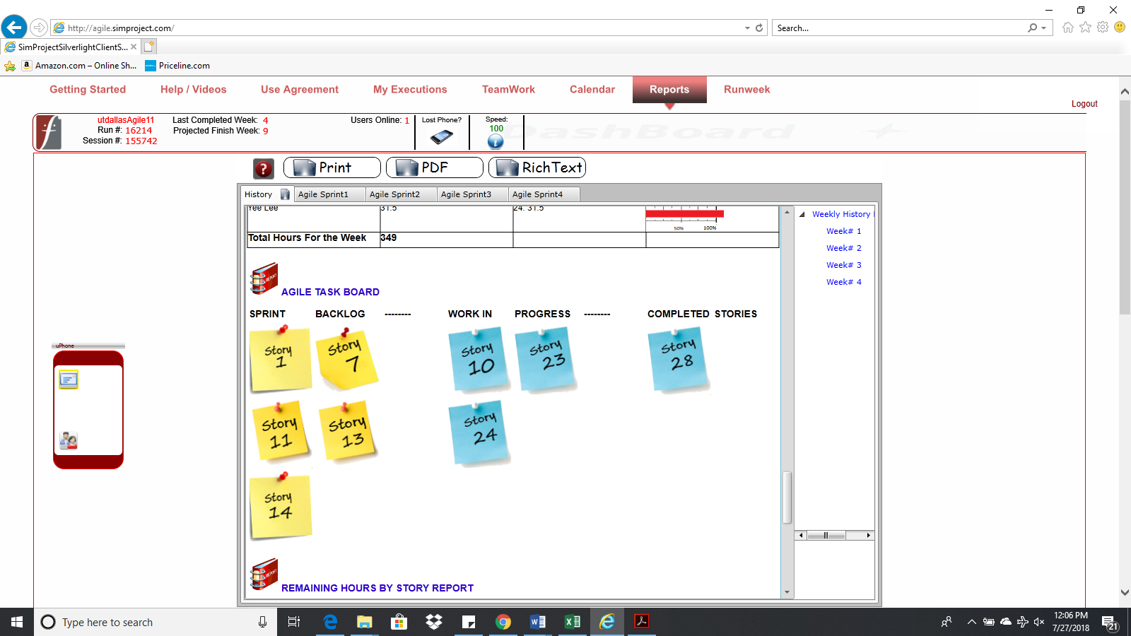

2nd Week Task Board Screen Shot**(1Points)**:

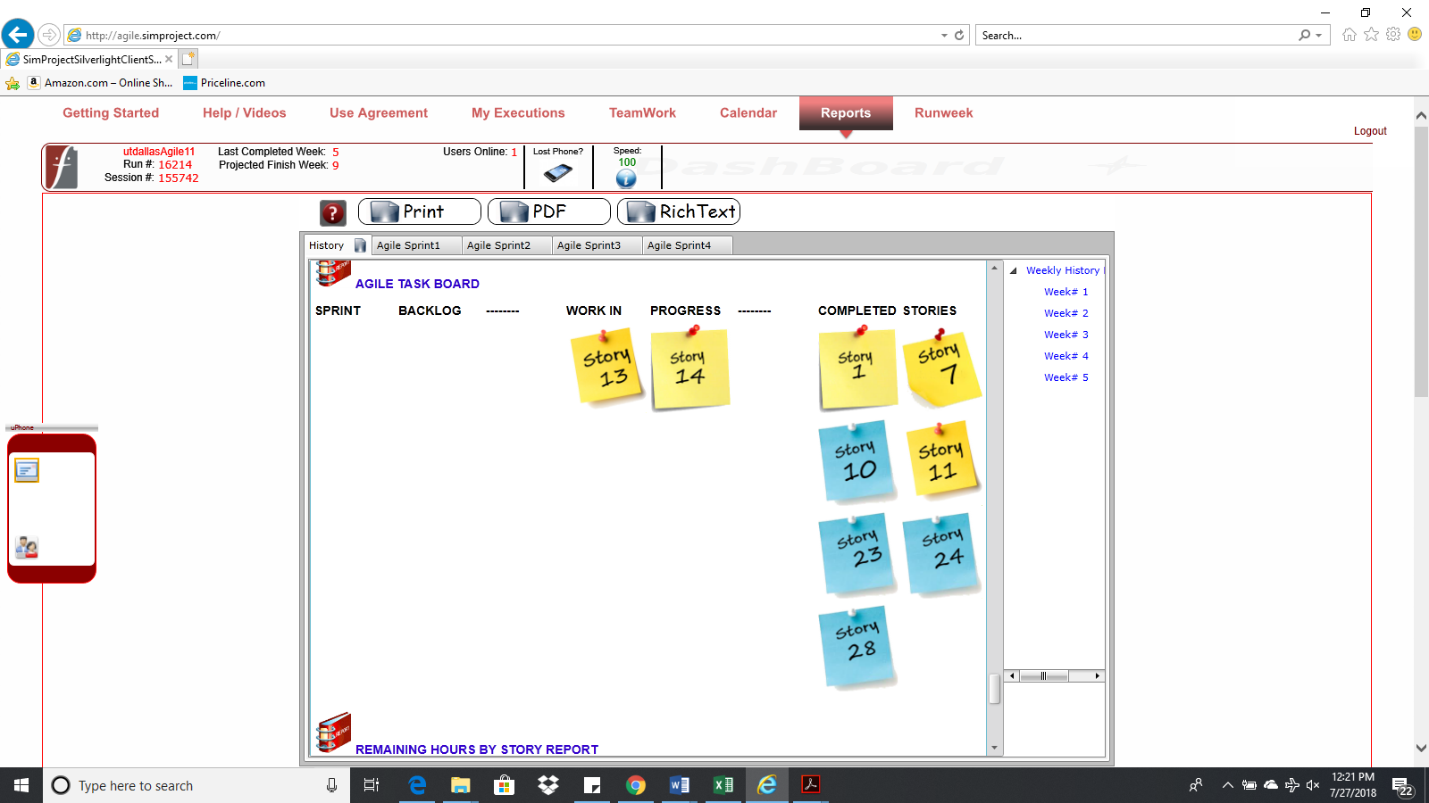

**BurnDown – EarnUp Chart**

* Paste the Sprint 2 Burn Down – Earn Up Chart below**(2Points)**:

|  |  |  |  |  |  |
| --- | --- | --- | --- | --- | --- |
| **Day** | **Planned Velocity** | **Remaining Hours** | **Story points earned** | **Cumulative Story Points Earned** | **Cumulative Business Value Earned** |
| 0 | 800 | 784 | 0 | 0 | 0 |
| 1 | 720 | 704 | 0 | 0 | 0 |
| 2 | 640 | 618 | 0 | 0 | 0 |
| 3 | 560 | 527 | 0 | 0 | 0 |
| 4 | 480 | 425 | 8 | 8 | 3 |
| 5 | 400 | 348 | 0 | 8 | 3 |
| 6 | 320 | 286 | 5 | 13 | 6 |
| 7 | 240 | 214 | 2 | 15 | 9 |
| 8 | 160 | 148 | 3 | 18 | 17 |
| 9 | 80 | 74 | 0 | 18 | 17 |
| 10 | 0 | 61 | 6 | 24 | 26 |

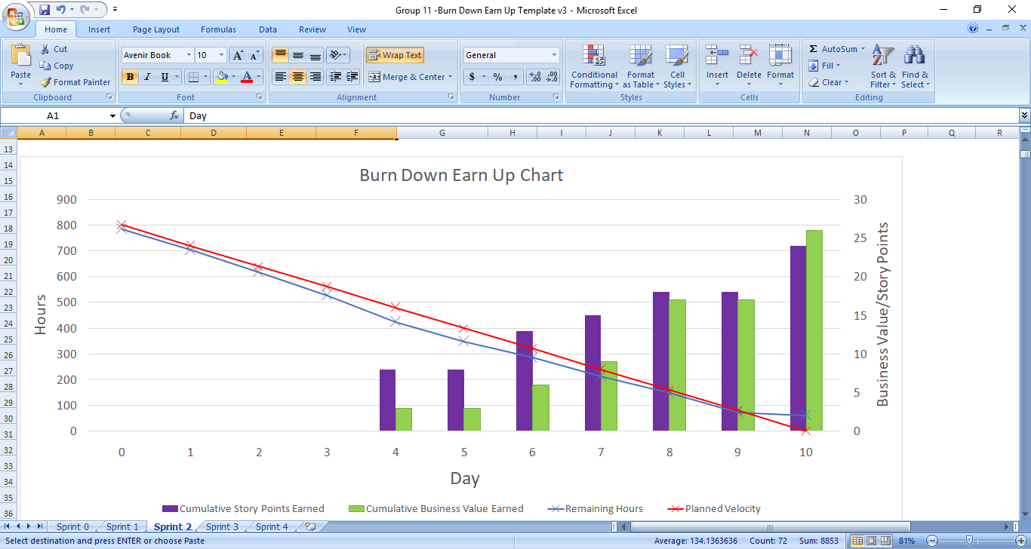

**Retrospective Meeting:**

* How did you do in this Sprint? **(2Points)**

We did quite well. Due to unforeseen circumstances we were not able to complete all the user stories, although the team tried their level best and we managed to complete 7 out of 9 user stories, which is not a bad performance. And we will try to accommodate the remaining user stories in the upcoming sprints.

* What changes you are planning to make in the next Sprint (if any)? **(2Points)**

The team did quite well in this sprint. We were unable to complete few user stories due to lack of resources and huge amount of effort hours. These will be accommodated first on priority and then the new user stories will be worked on. Apart from that everything else seems to work great. However, we’re halfway and we have never got out together for a lunch. That’ll be great. So, we’ll plan a free lunch for the entire team in the next sprint.

**Answer following questions based on above Sprint:**

1. How many hours did your team complete each week in the two weeks of above Sprint?   
   What is your average velocity per week (in hours), and your velocity range (in hours per week), using your lowest and highest hours/week in this project? **(2Points)**

Week 1 hours – 436

Week 2 hours – 287

Average velocity (hours/week) – 361.5

Velocity range(low) – 287hours/week

Velocity range(high)- 436 hours/week

2. What is your velocity (in story points) for this Sprint? **(2Points)**

Our velocity for this Sprint is 24 Story points.

3. Based on the current status of your project, do you believe that you will be able to complete the mandatory (or required) stories in the product backlog within the remaining sprints?  Explain your answer. **(2Points)**

Yes, we believe that we’ll be able to complete the required user stories as our grooming process involves prioritizing these user stories. Also, execution performance for both the sprints have shown great results.

4. Based on the current status of your project, do you believe that you will be able to complete all stories in the product backlog within the remaining sprints? Explain your answer. **(2Points)**

The average velocity in average hours per week was increased from 312 in sprint 1 to 361.5 in sprint 2. This looks good and we think that if continue to increase the average velocity, we can get other all the user stories completed as well. However, we’ll try not to let this velocity go down and only increase if possible, by appropriate planning.

**Sprint 3 - Week 6 & Week 7 (Possible Points: 24)**

**Product Backlog (one screen shot for both weeks)**

* Paste the screen shot of your Product Backlog below**(1Point)**:

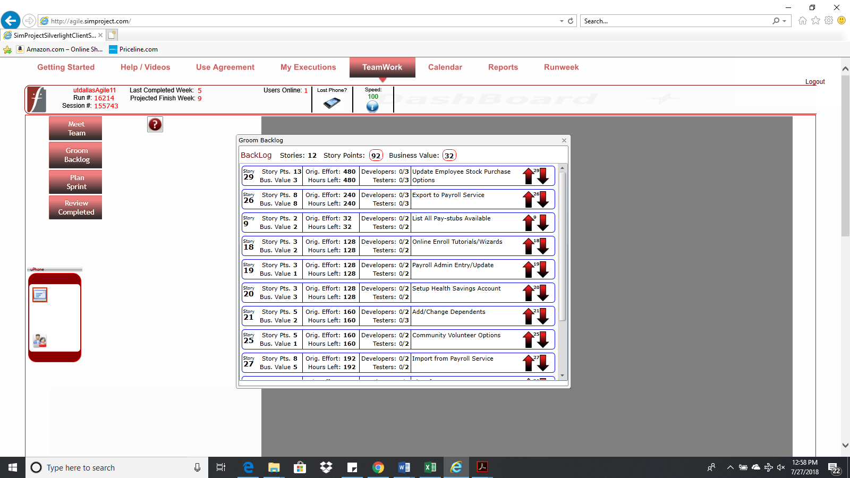

* Please explain what you did in grooming the user stories in your Product Backlog and your reasoning for these decisions **(2Points)**:

As all the required story points are completed, business value and availability of resources to accommodate in the sprint were given priority while grooming the user stories in our product backlog.

**Sprint Backlog (one screen shot for both weeks)**

* Paste the screen shot of your Sprint Backlog below **(1Point)**:

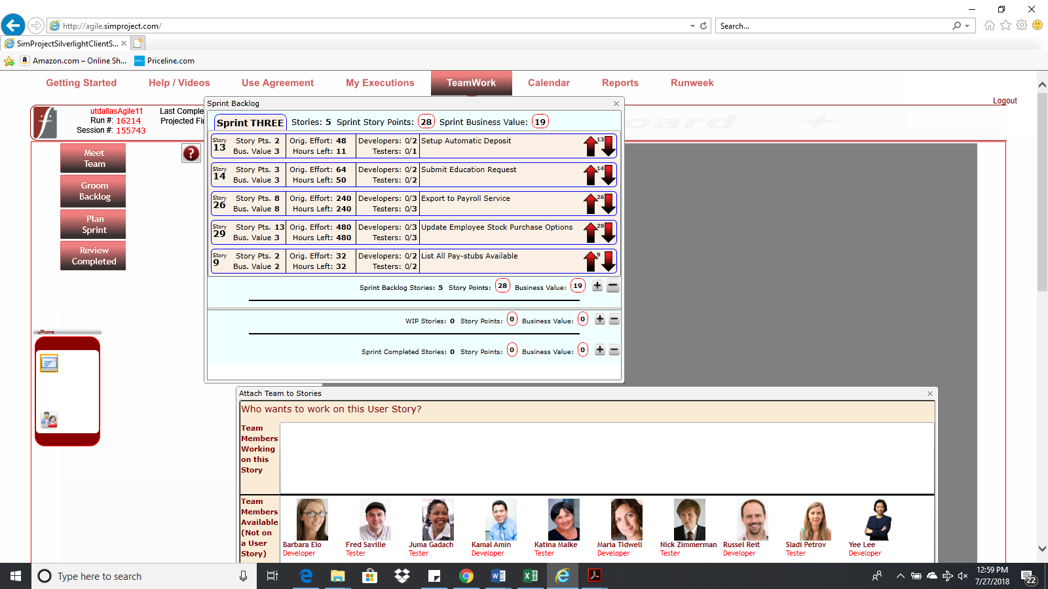

**Calendar**

* Paste the screen shot of your Calendar (one screen shot for 1stweek & one for 2nd week):

1st Week Calendar Screen Shot and explain the reason why you have scheduled these meetings (if any)? **(2Points)**

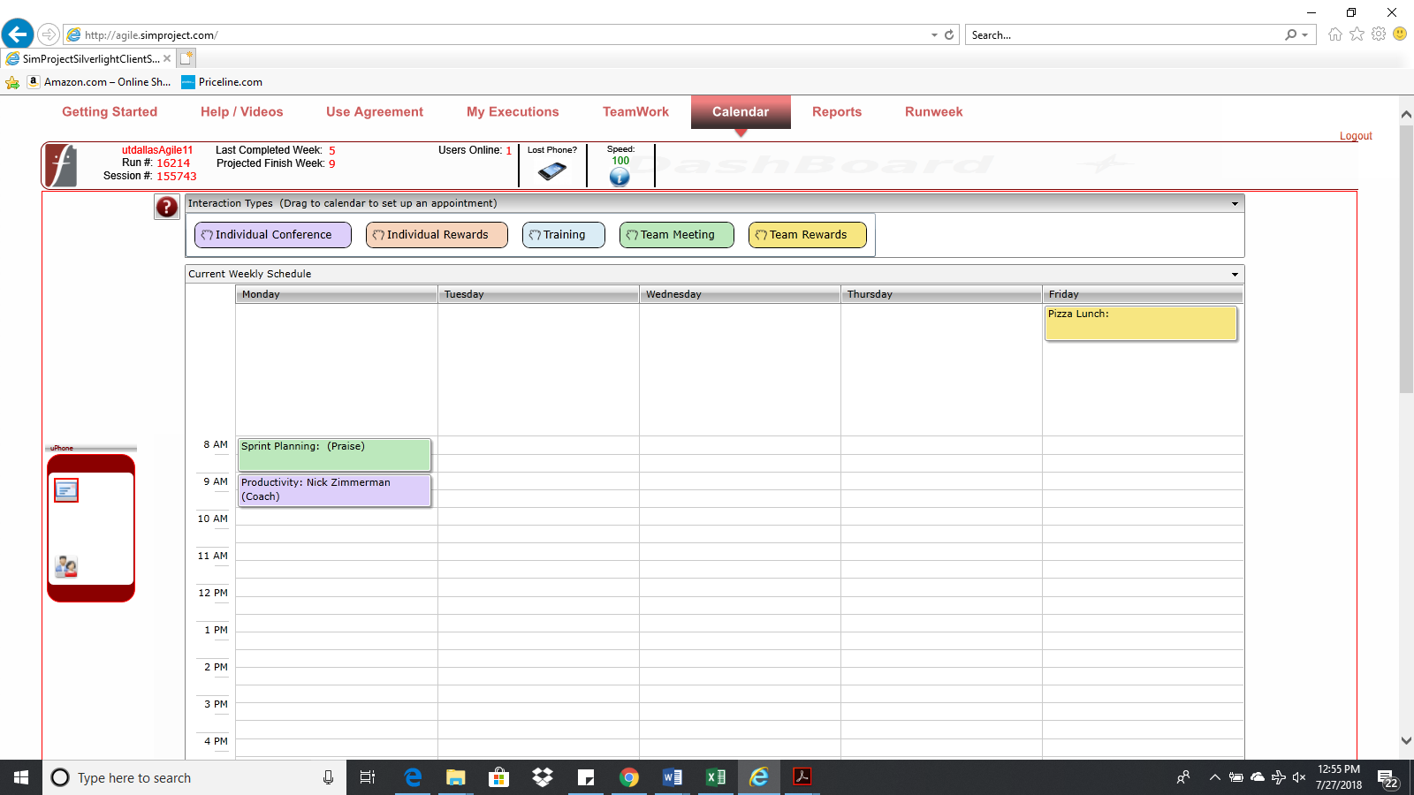

**Explanation:** A meeting was panned on Monday to plan the sprint for the next week. It was scheduled to run from 8AM-9AM. Also, there was a session planned on “Productivity” by Nick to coach the team from 9AM-10AM. Apart from that, we thought of planning Pizza Lunch on Friday to help create friendly relations among teammates.

2nd Week Calendar Screen Shot and explain the reason why you have scheduled these meetings (if any)? **(2Points)**

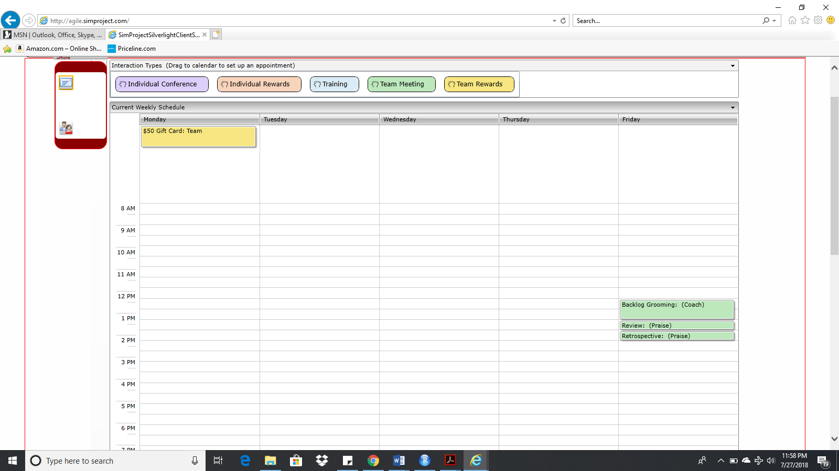

**Explanations:** We planned to give a $50 gift card on Monday to the team for their good performance and to keep them motivated and happy. Also, on Friday, we planned 3 meetings: Backlog Grooming from 12PM-1PM to groom the backlog for the next sprint, Sprint Review from 1PM-1:30PM to review the current sprint upon completion, and sprint retrospective from 1:30PM-2PM to retrospect and discuss any improvements or takeaways from the executed sprint.

**Task Board**

* Paste the screen shots of your Task Boards (one screen shot for 1stweek & one for 2nd week):

1st Week Task Board Screen Shot **(1Point)**

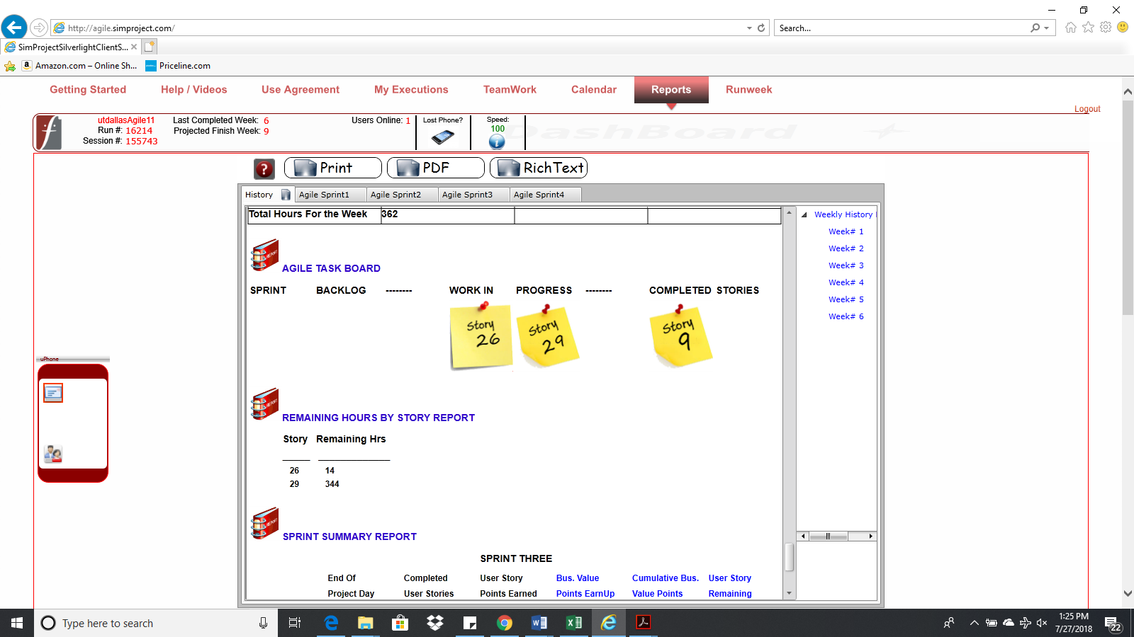

2nd Week Task Board Screen Shot**(1Point)**

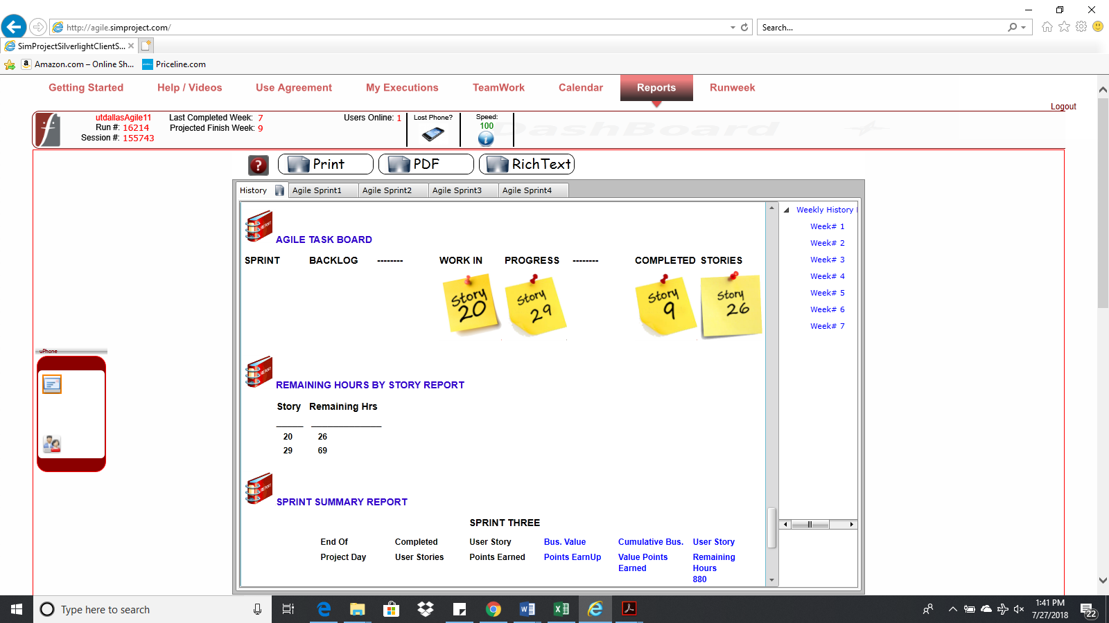

**BurnDown – EarnUp Chart**

* Paste the Sprint 3 Burn Down – Earn Up Chart below**(2Points)**:

|  |  |  |  |  |  |
| --- | --- | --- | --- | --- | --- |
| **Day** | **Planned Velocity** | **Remaining Hours** | **Story Points Earned** | **Cumulative Story Points Earned** | **Cumulative Business Value Earned** |
| 0 | 800 | 880 | 0 | 0 | 0 |
| 1 | 720 | 865 | 2 | 2 | 3 |
| 2 | 640 | 808 | 5 | 7 | 8 |
| 3 | 560 | 704 | 0 | 7 | 8 |
| 4 | 480 | 595 | 0 | 7 | 8 |
| 5 | 400 | 486 | 0 | 7 | 8 |
| 6 | 320 | 421 | 8 | 15 | 16 |
| 7 | 240 | 335 | 0 | 15 | 16 |
| 8 | 160 | 247 | 0 | 15 | 16 |
| 9 | 80 | 159 | 0 | 15 | 16 |
| 10 | 0 | 95 | 0 | 15 | 16 |

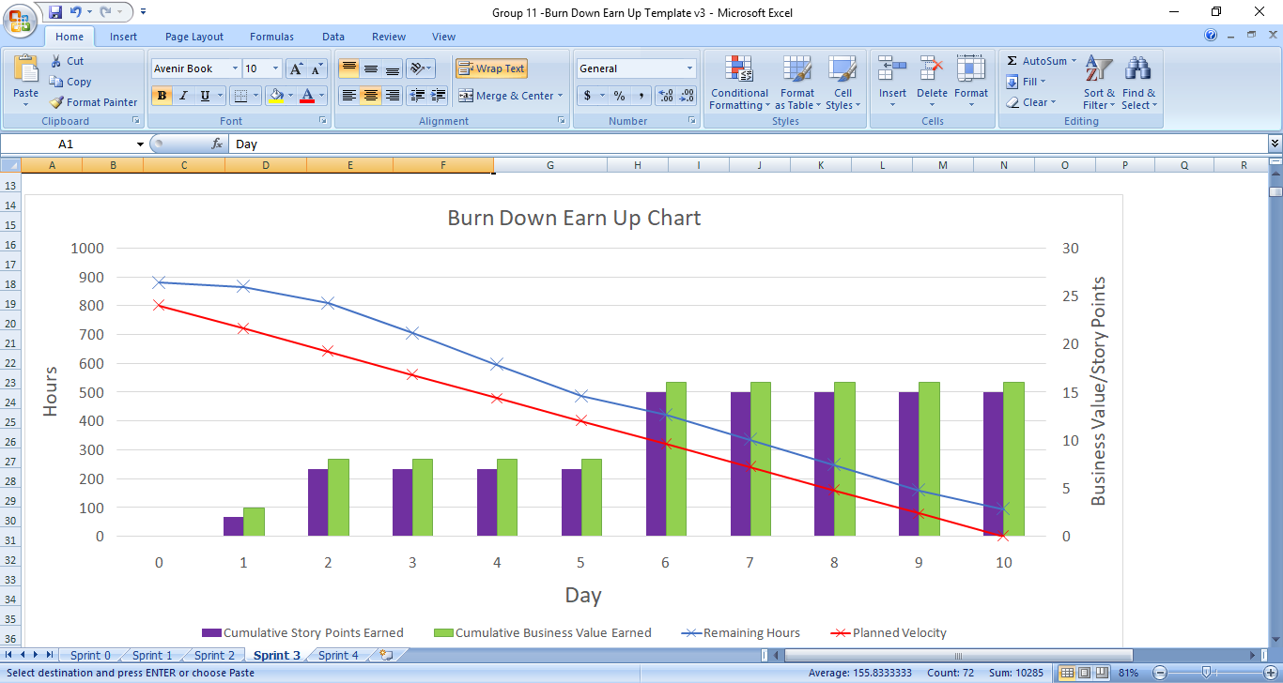

**Retrospective Meeting:**

* How did you do in this Sprint? **(2Points)**

In this sprint, the team completed remaining hours from previous sprint of 61 effort hours as well as delivered 2 new user stories that accounts for 683 effort hours out of 3 new user stories that accounted for 752 effort hours. The productivity of all the team members was more than 100% and the team delivered maximum story points compared to previous sprints.

* What changes are you planning to make in the next Sprint (if any)? **(2Points)**

One major change was new user requirements arose and we had to complete them before the next sprint ends. Since we have only one sprint left, we plan to finish the required stories first before the final sprint ends.

**Answer following questions based on this Sprint:**

1. How many hours did your team complete each week in the two weeks of above Sprint?   
What is your average velocity per week (in hours), and your velocity range (in hours per week), using your lowest and highest hours/week in this project as your range? **(2Points)**

Week 1 hours – 394

Week 2 hours – 391

Average velocity (hours/week) – 392.5

Velocity range(low) – 391hours/week

Velocity range(high)- 394 hours/week

2. What is your velocity (in story points) for this Sprint? What is your velocity range (in story points) overall? Please explain. **(2Points)**

Our velocity is 15 for this sprint. In sprint 1 we completed 23 story points while in Sprint 2 we completed 24 story points. So, our velocity ranges from 15 to 24.

3. Based on the current status of your project, do you believe that you will be able to complete the mandatory (or required) stories in the product backlog within the remaining sprints?  Explain your answer. **(2Points)**

Since, new required user stories have been added for the next sprint. We plan to finish them first, so we are hopeful and optimistic that we will be able to complete all the required user stories in the given time.

4. Based on the current status of your project, do you believe that you will be able to complete all stories in the product backlog within the remaining sprints? Explain your answer. **(2Points)**

Only 1 sprint remains after this and 5 new user stories have been added to the product backlog and the time duration of the project remains the same. Thus, we cannot complete all the user stories in the product backlog.

**Sprint 4 - Week 8 & Week 9 (Possible Points: 24)**

**Product Backlog (one screen shot for both weeks)**

* Paste the screen shot of your Product Backlog below**(1Point)**:

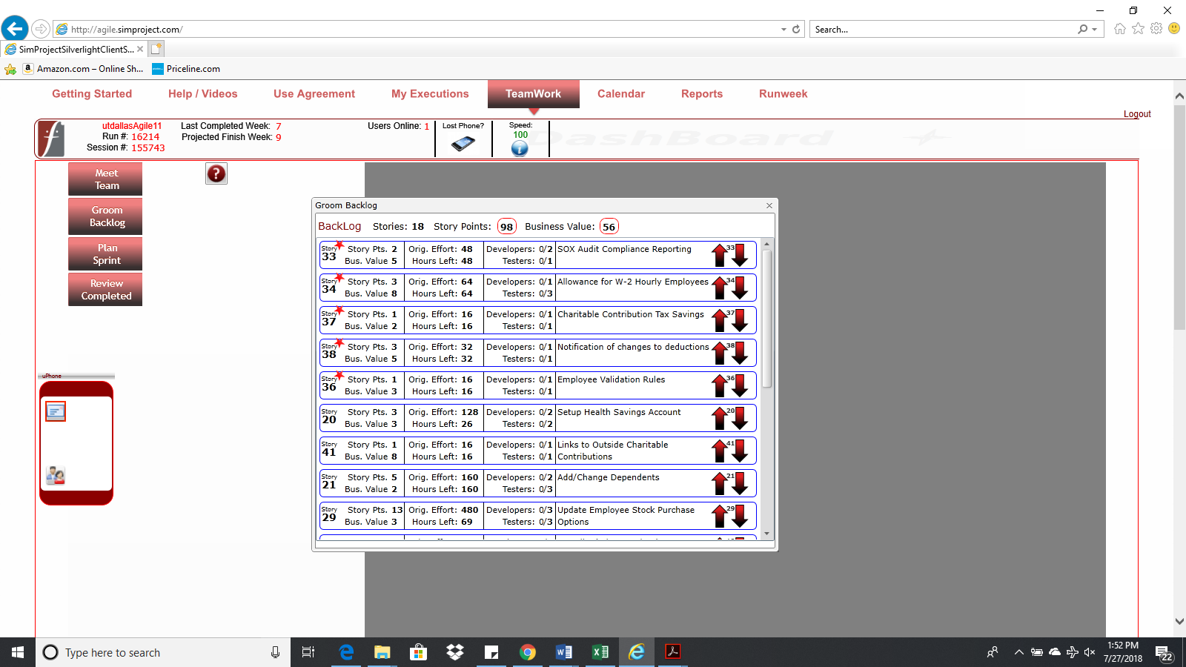

* Please explain what you did in grooming the user stories in your Product Backlog and your reasoning for these decisions **(2Points)**:

Additional user stories were added to the product backlog. We followed the same approach to give more priority to the additional required user stories. Business value earned per story point metric and availability of resources were considered next to groom the Product Backlog.

**Sprint Backlog (one screen shot for both weeks)**

* Paste the screen shot of your Sprint Backlog below **(1Point)**:

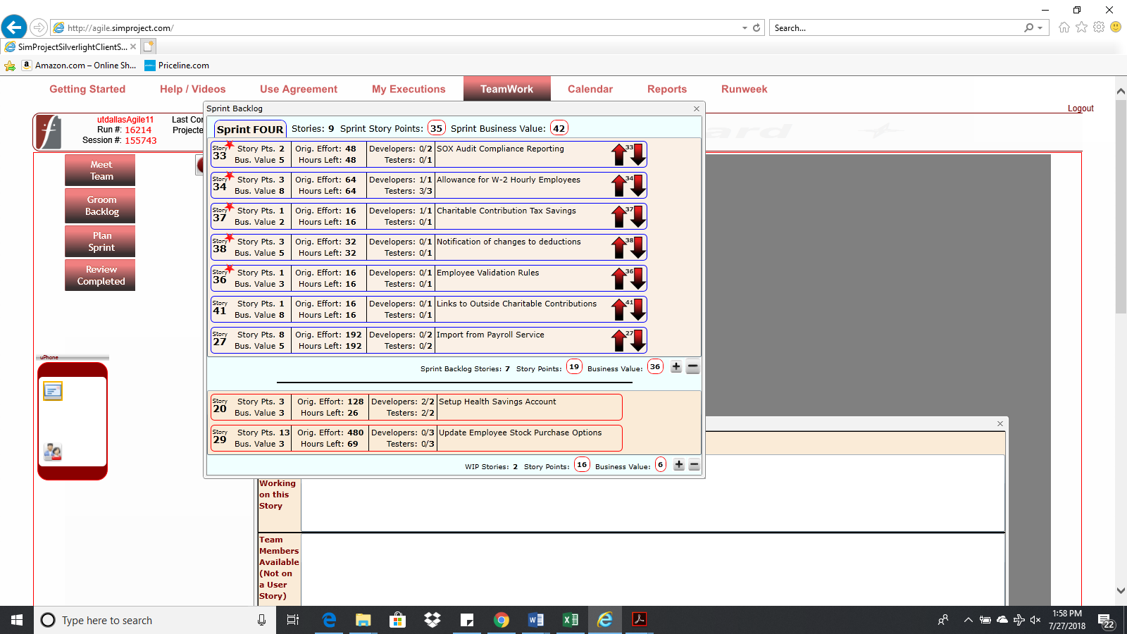

**Calendar**

* Paste the screen shot of your Calendar (one screen shot for 1stweek & one for 2nd week):

1st Week Calendar Screen Shot and explain the reason why you have scheduled these meetings (if any)? **(2Points)**

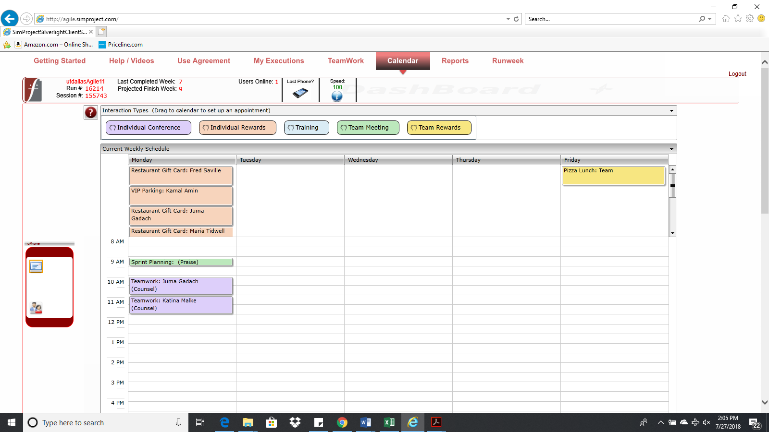

2nd Week Calendar Screen Shot and explain the reason why you have scheduled these meetings (if any)? **(2Points)**

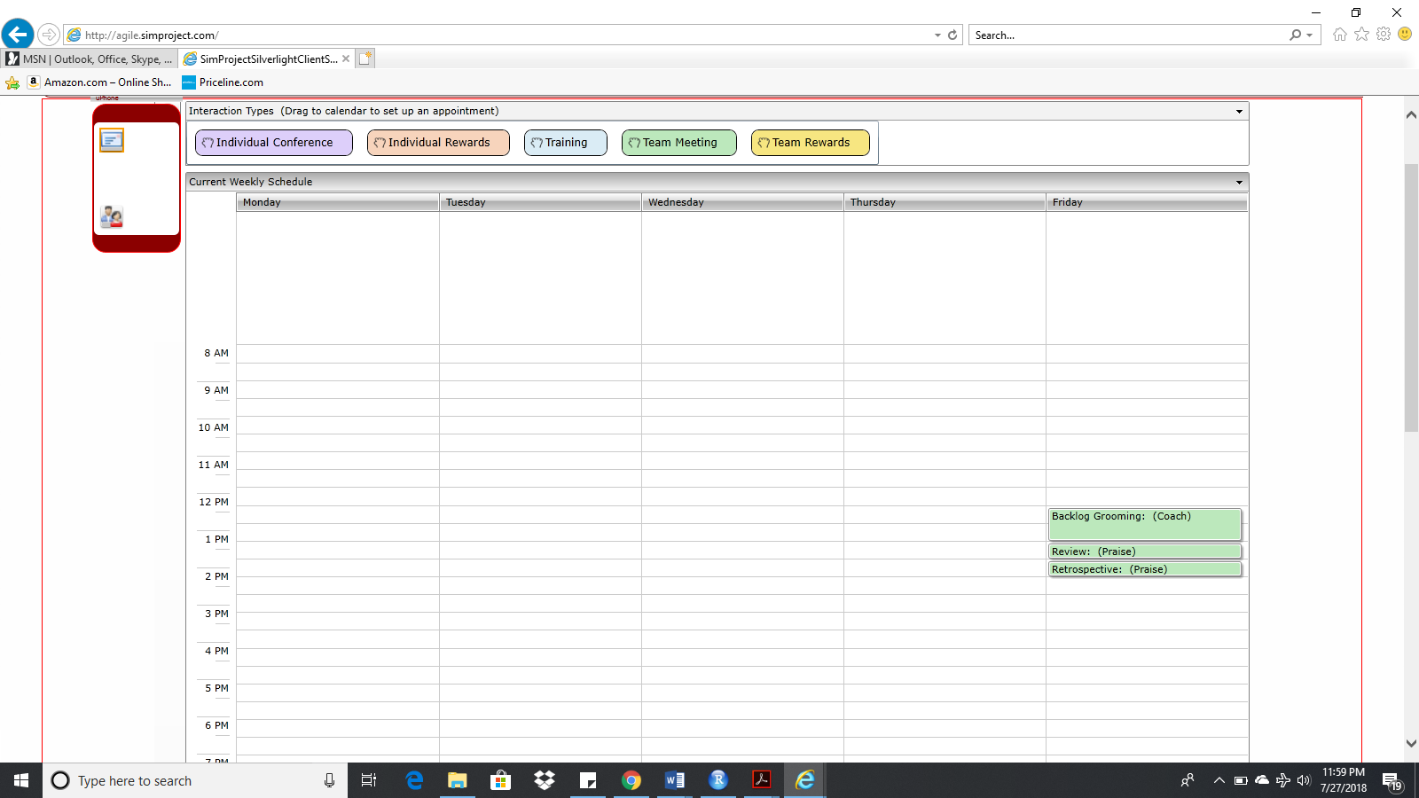

**Task Board**

* Paste the screen shots of your Task Boards (one screen shot for 1stweek & one for 2nd week):

1st Week Task Board Screen Shot **(1Point)**:

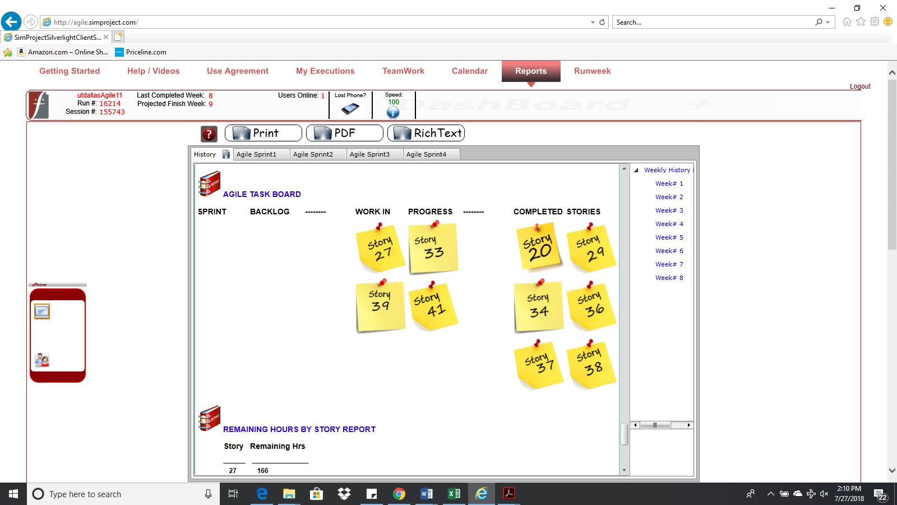

2nd Week Task Board Screen Shot**(1Points)**:

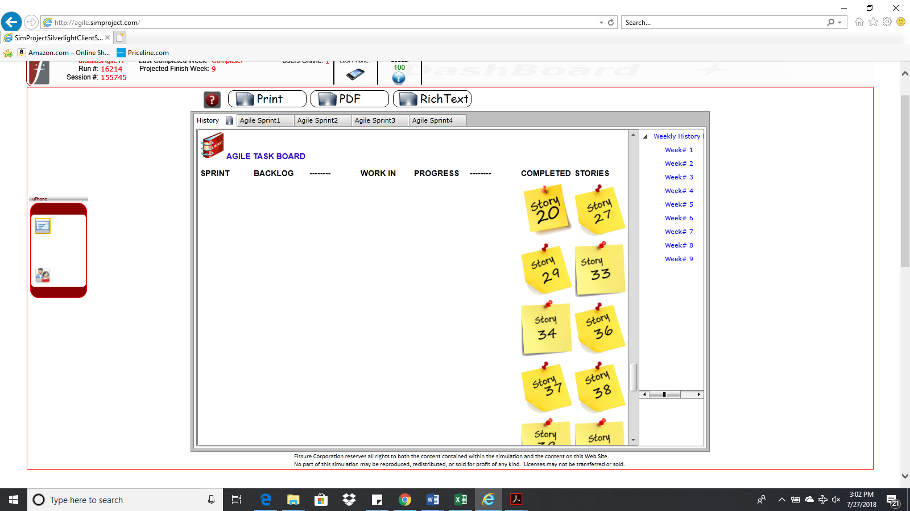

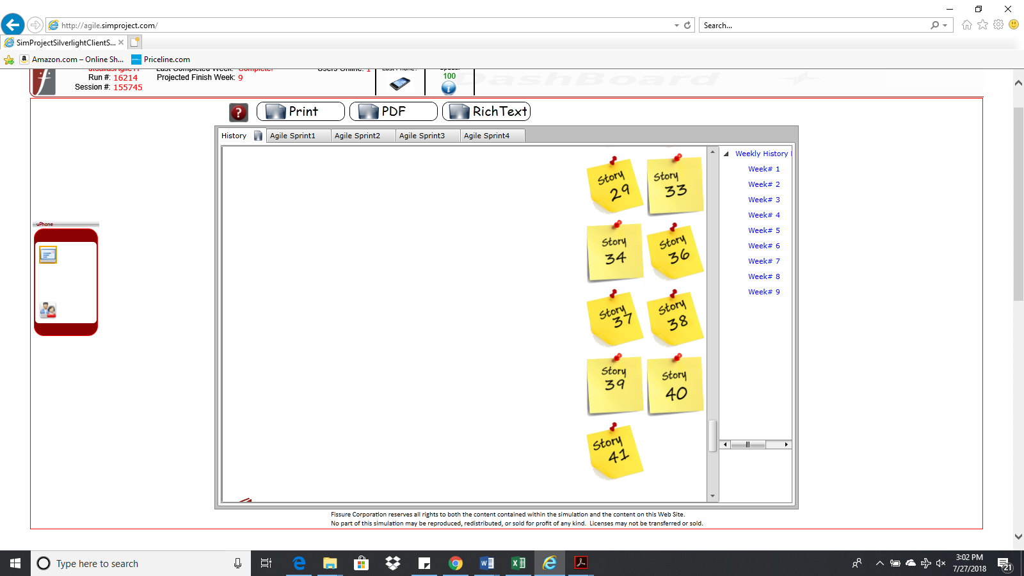

**BurnDown – EarnUp Chart**

* Paste the Sprint 4 Burn Down – Earn Up Chart below**(2Points)**:

|  |  |  |  |  |  |
| --- | --- | --- | --- | --- | --- |
| **Day** | **Planned Velocity** | **Remaining Hours** | **Story Points Earned** | **Cumulative Story Points Earned** | **Cumulative Business Value Earned** |
| 0 | 800 | 527 | 0 | 0 | 0 |
| 1 | 720 | 472 | 0 | 0 | 0 |
| 2 | 640 | 399 | 3 | 3 | 3 |
| 3 | 560 | 336 | 17 | 20 | 16 |
| 4 | 480 | 273 | 0 | 20 | 16 |
| 5 | 400 | 217 | 4 | 24 | 24 |
| 6 | 320 | 158 | 3 | 27 | 37 |
| 7 | 240 | 95 | 0 | 27 | 37 |
| 8 | 160 | 79 | 3 | 30 | 39 |
| 9 | 80 | 32 | 2 | 32 | 40 |
| 10 | 0 | 0 | 8 | 40 | 45 |

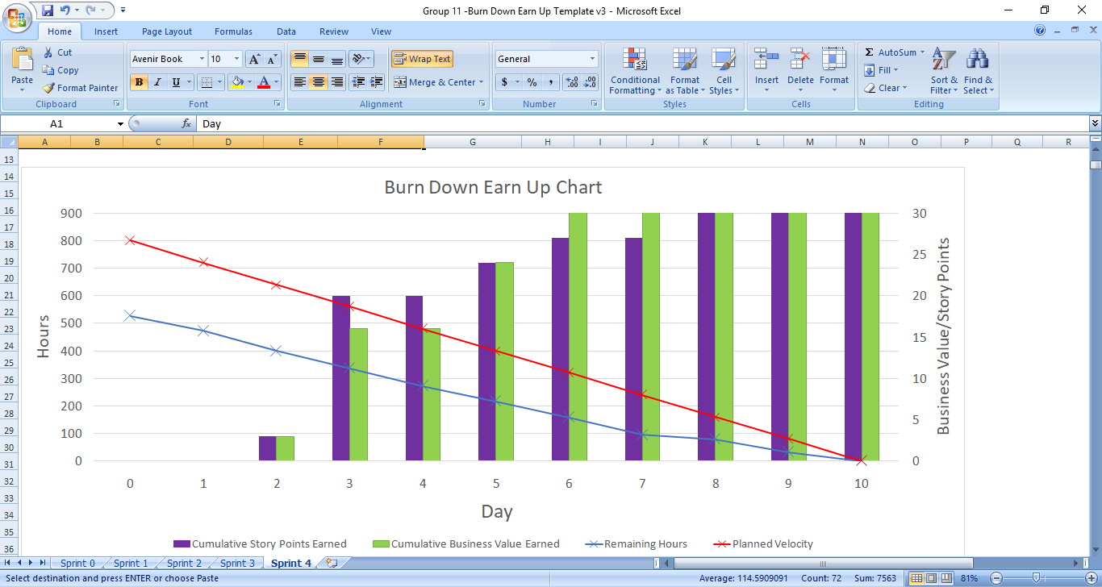

**Retrospective Meeting:**

* How did you do in this Sprint? **(2Points)**

As compared to all the previous sprints, team was able to deliver more than expected. The team delivered 40 story points which is almost twice as compared all the other sprints velocities. Hence, we have delivered exceptional work.

* Provide a critique of your performance. Discuss your performance, accomplishments and challenges in managing this project **(2Points)**:

Challenges:

1. Changes in the product backlog.

2. Not all the resources were 100% productive due to personal reasons such as marriage, doctor appointments, individual issues and difference of opinion within the team.

3. Team was not very actively participating in the sprint reviews and retrospectives.

4. Daily stand-up meeting were lengthy and time consuming.

Accomplishments:

1. Team pushed themselves very hard to deliver sprint velocity of 40 points.

2. Able to complete all the required user stories.

3. Team did very well apart from the issues they had within the team.

4. Daily stand-up meetings time duration reduced over the time and sprint review and retrospective meetings were more productive. Hence, team was able to follow the agile-scrum methodology.

Performance:

1. The team completed 103 story points out of 161 story points.

2. The team delivered all the required story points of business value of 146 points with only 11 business value points pending.

3. The team handled the product backlog changes well.

**Answer following questions based on this Sprint:**

1.  How many hours did your team complete each week in the two weeks of this Sprint?   
What is your average velocity per week (in hours), and your velocity range (in hours per week), using the highest and lowest hours/weeks throughout this project as the range? **(2Points)**

Week 1 hours – 310

Week 2 hours – 217

Average velocity (hours/week) – 263.5

Velocity range(low) – 217hours/week

Velocity range(high)- 310 hours/week

2. What is your velocity (in story points) for this Sprint? What is your velocity range (in story points) overall? Please explain. **(2Points)**

Velocity for this sprint is 40. The overall velocity range is 15 to 40 story points.

3. Based on the current status of your project, were you able to complete the mandatory (or required) stories in the product backlog?  Explain your answer. **(2Points)**

Yes, we were able to complete all the required stories. Our approach towards the grooming process played a key role in delivering our product with all the required user stories.

4. Based on the current status of your project, were you able to complete all stories in the product backlog? Explain your answer. **(2Points)**

No, we couldn’t complete all the stories in the product backlog. As we noticed by the end of sprint 4, 7 user stories of business value 11 were pending. Since, we were able to complete the 5 new required user stories as well as planned user stories in this sprint, we were not able to complete the remaining 7 user stories in product backlog that required more effort hours and resources.